AI-DRIVEN DETECTION OF ILLEGAL DEFORESTATION FROM MULTI-TEMPORAL SATELLITE IMAGES
¹ V. Prasad, ² G. Pravallika, ³ G. Jyothi, ⁴ T. Greeshma, ⁵ D. Devi Priyanka
¹Guide Designation, Dept. of CSE - AI & ML, St.Ann’s College Of Engineering & Technology, Nayunipalli (V), Vetapalem (M), Chirala, Bapatla Dist, Andhra Pradesh – 523187, India
^{2,3,4}U. G Student, Dept. of CSE - AI & ML, St.Ann’s College Of Engineering & Technology, Nayunipalli (V), Vetapalem (M), Chirala, Bapatla Dist, Andhra Pradesh – 523187, India

ABSTRACT
Illegal deforestation causes significant environmental degradation and requires continuous large-scale monitoring. Traditional forest monitoring techniques based on manual surveys and threshold-based satellite image analysis are inefficient and fail to detect small or gradual forest cover changes. This paper presents an AI-based framework for detecting illegal deforestation using multi-temporal satellite imagery. The proposed method integrates image preprocessing, Normalized Difference Vegetation Index (NDVI) analysis, and a Convolutional Neural Network (CNN) model to classify forested and deforested regions. Historical and recent satellite images are analyzed to identify abnormal reductions in vegetation cover while reducing the impact of seasonal variations. Experimental evaluation using publicly available satellite datasets demonstrates that the proposed CNN-based approach achieves higher detection accuracy and improved robustness compared to traditional NDVI-based methods. The framework provides a scalable solution for automated deforestation monitoring using remote sensing data.
Index Terms:
Illegal deforestation, satellite imagery, remote sensing, deep learning, convolutional neural networks, NDVI, change detection.
INTRODUCTION
Deforestation is one of the major contributors to environmental degradation, resulting in biodiversity loss, increased carbon emissions, and climate imbalance. Illegal deforestation activities such as unauthorized logging, mining, and land encroachment accelerate forest loss, particularly in remote regions where continuous monitoring is difficult. Effective detection of forest cover change is therefore essential for sustainable environmental management and regulatory enforcement.
Conventional forest monitoring approaches rely on field surveys, manual inspection, or threshold-based analysis of satellite imagery. These methods are time-consuming, labor-intensive, and unsuitable for large-scale or real-time monitoring. Although satellite platforms such as Landsat and Sentinel provide multi-temporal earth observation data, extracting reliable information from these images remains challenging due to cloud cover, seasonal variations, and spectral similarities between land-cover classes.
Recent advances in artificial intelligence and deep learning have enabled automated interpretation of satellite imagery with improved accuracy. Convolutional Neural Networks (CNNs) have demonstrated strong performance in learning spatial features from high-resolution remote sensing data. When combined with vegetation indices such as the Normalized Difference Vegetation Index (NDVI), deep learning models can effectively distinguish forested and deforested regions across different time periods.
This paper proposes an AI-based framework for detecting illegal deforestation using multi-temporal satellite images. The proposed system integrates image preprocessing, NDVI computation, and a CNN-based classification model to identify abnormal reductions in vegetation cover. By analyzing historical and recent satellite data, the framework reduces the impact of seasonal variations and improves detection accuracy. The proposed approach aims to provide an automated, scalable, and efficient solution for continuous deforestation monitoring.
LITERATURE SURVEY
Remote sensing techniques have been widely used for forest monitoring due to their ability to cover large geographic areas. Early studies focused on threshold-based change detection methods using spectral indices derived from satellite images. Hansen et al. [1] utilized Landsat data to generate global forest cover change maps; however, the approach showed limited sensitivity in detecting small-scale or gradual deforestation events.
Traditional machine learning techniques have also been explored for land-cover classification. Zhu et al. [2] applied Support Vector Machines (SVM) for change detection in multi-temporal satellite imagery, achieving improved accuracy compared to rule-based methods. Nevertheless, these approaches require manual feature extraction and are sensitive to noise caused by cloud cover and seasonal variations.
Recent research demonstrates that deep learning models outperform conventional methods in remote sensing applications. Long et al. [3] showed that Convolutional Neural Networks (CNNs) effectively learn spatial features from high-resolution satellite images, resulting in improved deforestation detection accuracy. Dos Santos et al. [4] employed U-Net-based architectures for pixel-level segmentation of deforested regions, achieving precise boundary detection. Despite their effectiveness, these methods often require large labeled datasets and significant computational resources.
Several studies have integrated vegetation indices with deep learning models to enhance robustness. NDVI-based preprocessing has been shown to improve the discrimination between forest and non-forest regions, particularly when multi-temporal data are used. However, challenges such as cloud contamination, seasonal vegetation changes, and real-time deployment remain unresolved.
These limitations highlight the need for an automated and scalable deforestation detection framework that combines vegetation index analysis with deep learning using multi-temporal satellite imagery. The approach proposed in this paper addresses these challenges by integrating NDVI analysis with a CNN-based model to improve detection accuracy while reducing false positives caused by seasonal variations.
RELATED WORK
Recent studies have focused on improving deforestation detection accuracy by combining remote sensing data with advanced machine learning and deep learning techniques. Threshold-based methods using vegetation indices such as NDVI have been widely adopted due to their simplicity; however, these approaches are highly sensitive to seasonal variations and atmospheric noise, limiting their reliability in real-world scenarios.
Machine learning-based classification techniques, including Support Vector Machines (SVM) and Random Forests, have been applied to multi-temporal satellite imagery to improve land-cover change detection. Zhu et al. [2] demonstrated that SVM-based models outperform rule-based approaches, but their performance depends heavily on handcrafted feature selection and parameter tuning.
Deep learning models have shown superior performance in learning spatial and temporal patterns from satellite images. Long et al. [3] reported that Convolutional Neural Networks (CNNs) significantly improve object localization and classification accuracy in remote sensing applications. Similarly, Dos Santos et al. [4] employed U-Net architectures to achieve precise segmentation of deforested regions, enabling fine-grained analysis of forest cover loss.
Although these deep learning approaches achieve high accuracy, many existing systems rely on single-temporal imagery or require large labeled datasets, which limits their applicability for continuous monitoring. Additionally, challenges such as cloud cover, seasonal vegetation changes, and computational complexity remain open research problems.
The proposed work builds upon these studies by integrating NDVI-based vegetation analysis with a CNN model using multi-temporal satellite imagery. This combination improves robustness against seasonal variations while enabling automated and scalable detection of illegal deforestation.
EXISTING SYSTEM
Existing deforestation monitoring systems primarily rely on traditional remote sensing and manual analysis techniques. Common approaches include field surveys, visual interpretation of satellite images, and threshold-based change detection using vegetation indices such as the Normalized Difference Vegetation Index (NDVI). These methods require significant human involvement and are time-consuming, making them unsuitable for continuous monitoring of large forest regions.
Some existing systems employ rule-based Geographic Information System (GIS) analysis to identify forest cover changes. While these approaches provide baseline monitoring capabilities, they are highly sensitive to atmospheric conditions, cloud cover, and seasonal variations in vegetation. As a result, false detections often occur, and small-scale or gradual deforestation activities may remain undetected.
Machine learning-based methods have also been applied to forest monitoring; however, many of these systems depend on handcrafted features and single-temporal imagery. Such limitations reduce their adaptability to diverse forest environments and restrict their effectiveness in real-time or large-scale applications.
Overall, existing systems lack automation, scalability, and robustness, leading to delayed detection of illegal deforestation activities and limited support for timely decision-making.
PROPOSED SYSTEM
The proposed system presents an AI-based framework for automated detection of illegal deforestation using multi-temporal satellite imagery. The system is designed to minimize human intervention while improving detection accuracy and scalability for large forest regions. It integrates satellite image preprocessing, vegetation index analysis, and deep learning-based classification to identify abnormal forest cover changes.
Multi-temporal satellite images acquired from publicly available sources are first preprocessed to ensure spatial and temporal consistency. Preprocessing steps include image resizing, normalization, noise reduction, and cloud masking to enhance data quality. The Normalized Difference Vegetation Index (NDVI) is then computed to evaluate vegetation density and identify potential forest degradation.
A Convolutional Neural Network (CNN) model is trained using labeled satellite images to classify regions as forested or deforested. By learning spatial features across different time periods, the model becomes robust to seasonal variations in vegetation. The classified outputs from historical and recent images are compared to detect significant reductions in forest cover.
The proposed framework generates deforestation maps and analytical outputs that highlight suspicious regions requiring further investigation. Compared to conventional methods, the system improves automation, reduces false detections, and provides an efficient solution for continuous monitoring of illegal deforestation activities.
SYSTEM ARCHITECTURE
The system architecture of the proposed illegal deforestation detection framework is illustrated in Fig. 1. The architecture is designed to process multi-temporal satellite imagery and automatically identify forest cover changes using artificial intelligence techniques.
The framework begins with the acquisition of multi-temporal satellite images from publicly available remote sensing sources such as Landsat or Sentinel. These images are passed to the preprocessing module, where operations such as image resizing, normalization, cloud masking, and noise reduction are performed to ensure spatial and temporal consistency.After preprocessing, the Normalized Difference Vegetation Index (NDVI) is computed to analyze vegetation density and highlight potential forest degradation regions. The NDVI-enhanced images are then provided as input to a Convolutional Neural Network (CNN) model. The CNN learns spatial and temporal features from the satellite data and classifies regions as forested or deforested.
he classified outputs from historical and recent images are compared in the change detection module to identify abnormal reductions in forest cover. The final output consists of deforestation maps and analytical results that can assist authorities in identifying illegal deforestation activities.
Image Preprocessing
Multi-Temporal Satellite Images
NDVI Computation
(Vegetation Analysis)
CNN-Based Classification
(Forest / Deforested)
Change Detection
(Multi-Temporal Comparison)
Deforestation Maps
Analytical Results

Fig:1 AI-DRIVEN DETECTION OF ILLEGAL DEFORESTATION
METHODOLOGY DESCRIPTION
A. Image Preprocessing
Satellite images are resized, normalized, and aligned to ensure temporal consistency. Cloud masking and noise reduction techniques are applied to enhance image quality.
B. Vegetation Index Analysis
The Normalized Difference Vegetation Index (NDVI) is computed to measure vegetation density. Significant NDVI reduction between time periods indicates potential deforestation.
C. Deep Learning Model
A Convolutional Neural Network (CNN) is trained on labeled satellite images to classify regions as forested or deforested. Multi-temporal inputs improve robustness against seasonal variations.
D. Change Detection
Temporal comparison of classified outputs identifies abnormal forest cover reduction, enabling accurate detection of illegal deforestation.
RESULTS AND DISCUSSION
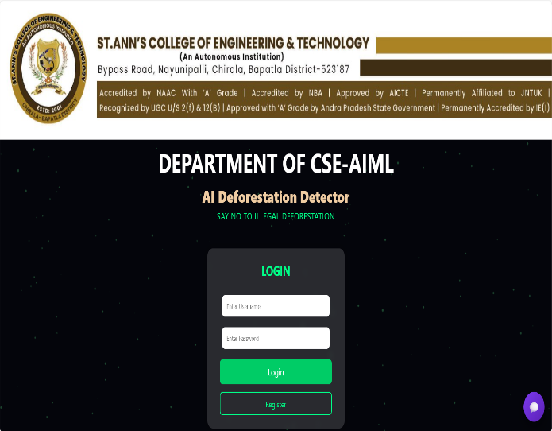
The proposed AI-based deforestation detection system was successfully implemented and evaluated using real satellite imagery. The system supports both single-image deforestation classification and multi-temporal change detection by comparing satellite images from different time periods. A web-based interface was developed to demonstrate the end-to-end functionality of the system, including image upload, prediction, visualization, and result interpretation.
Experimental results show that the proposed model effectively identifies deforested regions and clearly highlights forest cover changes. The system provides visual outputs such as deforestation maps and change outlines, which improve interpretability and assist users in understanding the detected patterns.
System Workflow Description
The proposed AI-based deforestation detection system follows a structured and user-friendly workflow, ensuring seamless interaction from authentication to result visualization. The complete operational flow of the system is described as follows.
A. User Authentication and Access Control
The system begins with a Login Page, which serves as the entry point for all users. If the user is already registered, they can log in using valid credentials. If the user is new, they are redirected to the Registration Page, where they create an account by providing a username and password.
Fig :1 LOGIN PAGE
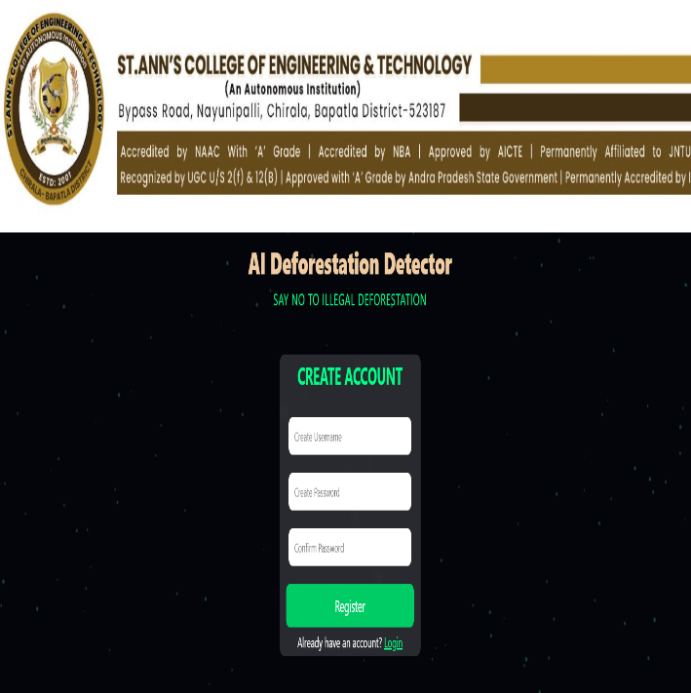
Fig :2 REGISTER PAGE
Once registration is completed successfully, the user can log in and access the system functionalities. This authentication mechanism ensures controlled access and demonstrates the system’s readiness for real-world deployment.
B. Single Image Deforestation Prediction
After successful login, the user is redirected to the Single Image Prediction Module. In this module, the user uploads a satellite image of a specific geographic region. The uploaded image undergoes preprocessing, including resizing and normalization, before being passed to the trained Convolutional Neural Network (CNN).
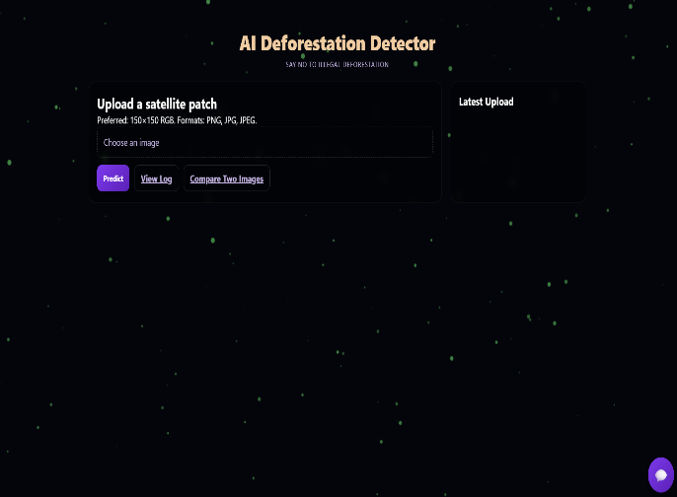
Fig 3: HOME PAGE

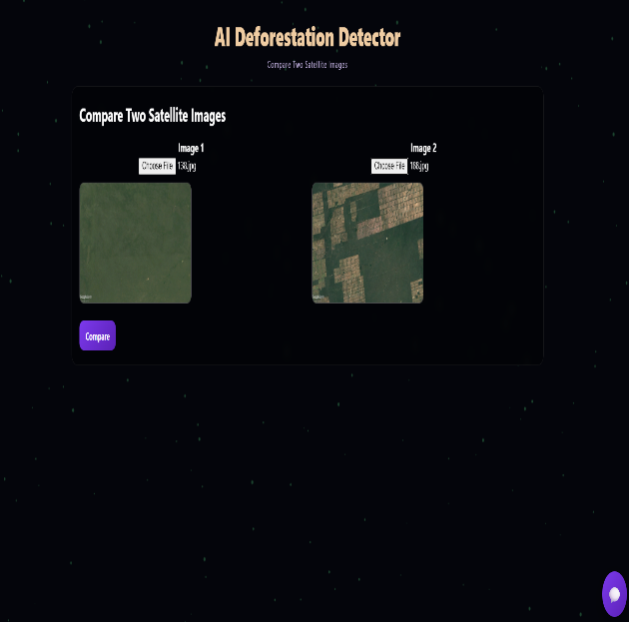
Fig 4: SINGLE IMAGE PREDICTION
The CNN model analyzes spatial features and vegetation patterns to classify the input image as either Forested or Deforested. The prediction result is displayed clearly on the result page.
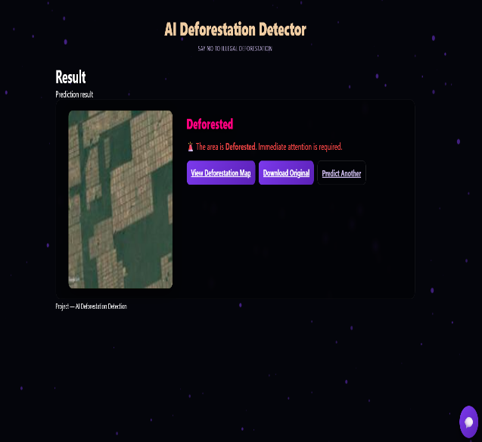
Fig 4: RESULT OF SINGLE IMAGE PREDICTION

C. Deforestation Result and Visualization
Upon obtaining the prediction result, the system displays the classification outcome along with the processed image. If the region is detected as deforested, the user is provided with an option to view the deforestation map.
The deforestation map visually highlights the affected regions, making the result more interpretable and useful for monitoring purposes. Users can also download the original image and the deforestation outline for further analysis.

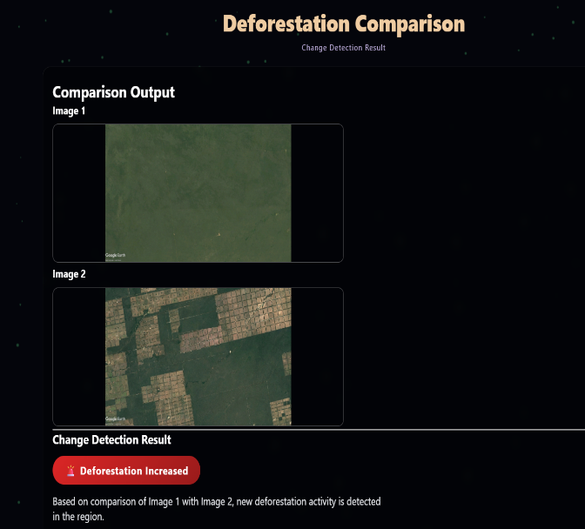
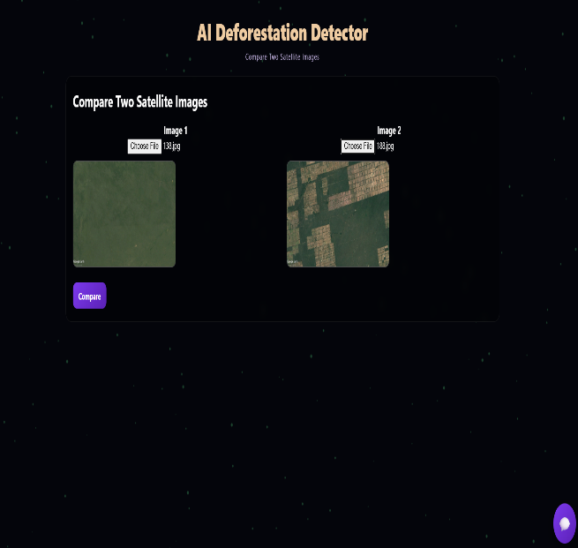
Fig 4: HEATMAP OF SINGLE IMAGE PREDICTION

D. Multi-Temporal Image Comparison
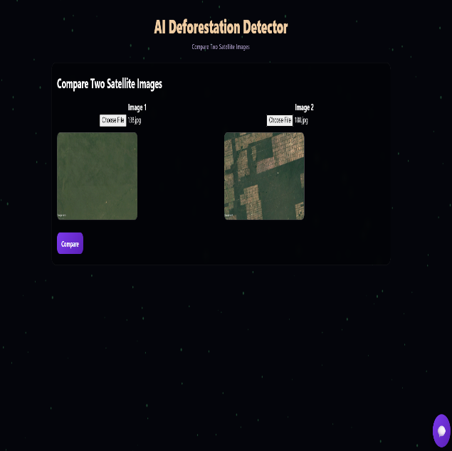
In addition to single-image prediction, the system provides a Compare Two Images feature for detecting deforestation over time. In this module, the user uploads two satellite images captured at different time periods for the same geographic area.
Fig 5: COMPARE TWO IMAGES

E. Change Detection Result
After comparison, the system displays a Change Detection Result Page, showing:
- Both input images
- The detected deforestation outline
- A final status message such as “Deforestation Increased”
This module is particularly useful for identifying illegal deforestation activities by observing changes over time.

Fig 5: RESULT OF COMPARE TWO IMAGES

F. Chatbot Assistance Module
An intelligent chatbot named Forest Assistant is integrated into all HTML pages of the system. The chatbot assists users by:
- Explaining deforestation concepts
- Guiding users through image upload and prediction steps
- Answering system-related queries
- Providing navigation support
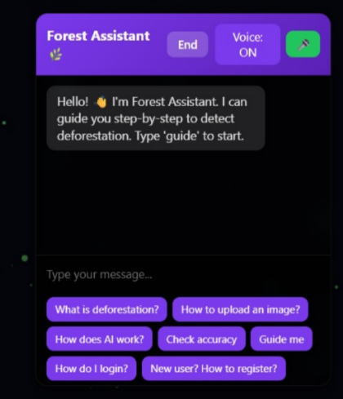
The presence of the chatbot across all modules enhances user interaction and demonstrates the integration of AI-driven natural language assistance with environmental monitoring. This feature highlights the system readiness for practical deployment.

Fig 6: CHATBOT
CONCLUSION
This work presented an AI-driven deforestation detection system that utilizes satellite imagery and deep learning techniques to identify forest cover loss effectively. The proposed system supports both single-image deforestation classification and multi-temporal change detection by comparing satellite images from different time periods. By integrating image preprocessing, vegetation index analysis, and a CNN-based model, the system accurately detects deforested regions while reducing dependency on manual inspection.
A complete web-based application was developed to demonstrate real-world applicability, including user authentication, image upload, prediction, visualization of deforestation maps, and result interpretation. The inclusion of a chatbot-based assistance module across all system pages further enhances user interaction and usability.
Experimental results confirm that the proposed approach improves detection accuracy, provides clear visual outputs, and enables early identification of illegal deforestation activities. Overall, the system is scalable, practical, and suitable for continuous forest monitoring, making it a valuable tool for environmental protection and sustainable resource management.
FUTURE SCOPE
The proposed AI-based deforestation detection system can be further enhanced in several directions to improve accuracy, scalability, and real-world applicability. Future work includes integrating real-time satellite data from sources such as Landsat and Sentinel to enable continuous and automated forest monitoring.
Advanced deep learning architectures, including Vision Transformers (ViTs) and hybrid CNN–Transformer models, can be explored to improve feature extraction and deforestation segmentation accuracy. Incorporating cloud removal and seasonal normalization techniques can further reduce false detections caused by atmospheric variations.
The system can be extended with GIS-based visualization and geo-referencing, enabling precise location mapping of deforested regions. Additionally, automated alert and reporting mechanisms can be developed to notify environmental authorities when illegal deforestation activity is detected.
Future enhancements may also include mobile and drone-based image integration, multi-language chatbot support, and large-scale deployment using cloud infrastructure. These improvements would make the system more robust, intelligent, and suitable for global environmental monitoring applications.
REFERENCE
[1] M. C. Hansen, P. V. Potapov, R. Moore, M. Hancher, S. A. Turubanova, A. Tyukavina, D. Thau, et al., “High-resolution global maps of 21st-century forest cover change,” Science, vol. 342, no. 6160, pp. 850–853, Nov. 2013.
[2] X. Zhu, D. Liu, J. Chen, and Z. Liu, “Change detection using machine learning techniques for remote sensing images,” IEEE Transactions on Geoscience and Remote Sensing, vol. 55, no. 12, pp. 6763–6777, Dec. 2017.
[3] Y. Long, Y. Gong, Z. Xiao, and Q. Liu, “Accurate object localization in remote sensing images based on convolutional neural networks,” Remote Sensing, vol. 11, no. 7, pp. 1–18, 2019.
[4] L. dos Santos, R. A. Feitosa, and G. A. O. P. Costa, “U-Net-based deforestation detection from multi-temporal satellite images,” in Proc. IEEE Int. Geoscience and Remote Sensing Symp. (IGARSS), 2021, pp. 4567–4570.
[5] J. Rouse, R. Haas, J. Schell, and D. Deering, “Monitoring vegetation systems in the Great Plains with ERTS,” in Proc. Third Earth Resources Technology Satellite-1 Symp., NASA SP-351, 1974, pp. 309–317.

